**ASSIGNMENT 3**

|  |  |
| --- | --- |
| Assignment Date | 23 September 2022 |
| Student Name | Laxmi Narayana Sagar M |
| Student Roll Number | 950819104026 |
| Maximum Marks | 2 Marks |

1. Create a bucket in IBM cloud storage.

**Solution:**

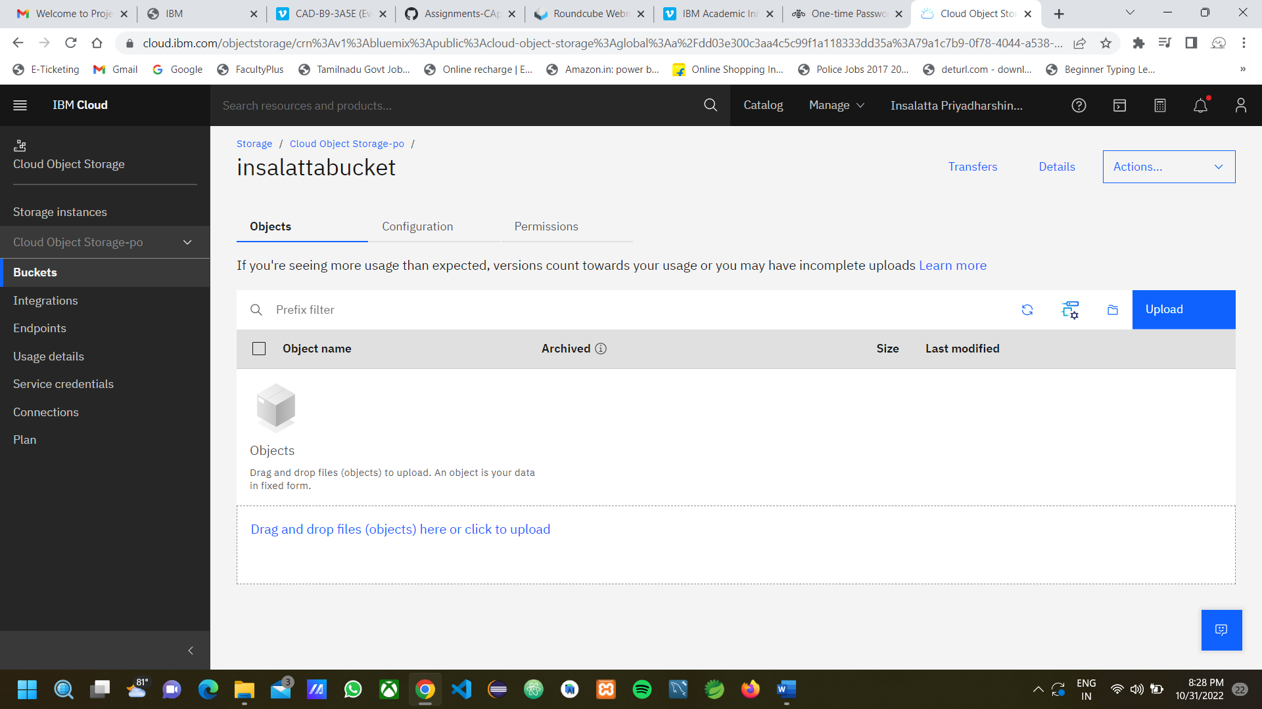

1. Upload 5 images to IBM object storage and make it public. write html code for displaying all the 5 images.

**Solution:**

Uploaded 5 images to IBM object storage.

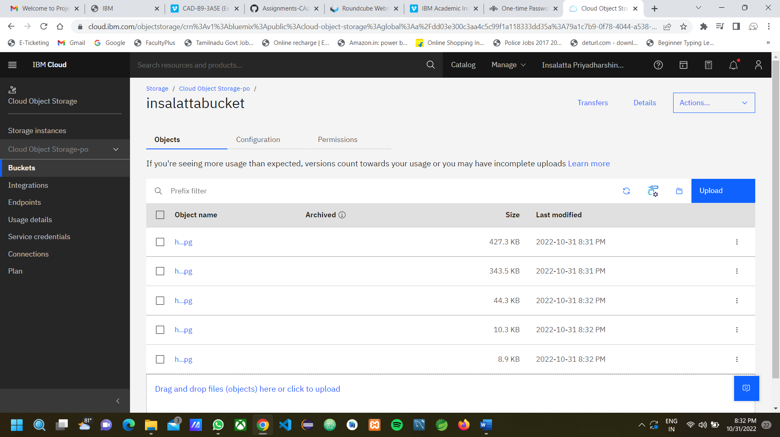

HTML code for displaying all five images

index.html

<!DOCTYPE html>

<html>

    <head>

        <title>IBM Cloud Storage</title>

        <Link rel="stylesheet" href="index.css">

    </head>

    <body>

        <h2>Harry Potter Books</h2>

        <div class="wrapper">

            <div>

                <p>Harry potter book part 1 image</p>

                <img src="http://s3.us-east.cloud-object-storage.appdomain.cloud/insalattabucket/h1.jpg" alt="Harry Potter Part 1">

            </div>

            <div>

                <p>Harry potter book part 2 image </p>

            <img src="http://s3.us-east.cloud-object-storage.appdomain.cloud/insalattabucket/h2.jpg" alt="Harry Potter Part 1">

            </div>

            <div>

                <p>Harry potter book part 3 image</p>

            <img src="http://s3.us-east.cloud-object-storage.appdomain.cloud/insalattabucket/h3.jpg" alt="Harry Potter Part 1">

            </div>

            <div>

                <p>Harry potter book part 4 image</p>

            <img src="http://s3.us-east.cloud-object-storage.appdomain.cloud/insalattabucket/h4.jpg" alt="Harry Potter Part 1">

            </div>

            <div>

                <p>Harry potter book part 6 image</p>

            <img src="http://s3.us-east.cloud-object-storage.appdomain.cloud/insalattabucket/h6.jpg" alt="Harry Potter Part 1">

            </div>

        </div>

    </body>

</html>

**Output:**

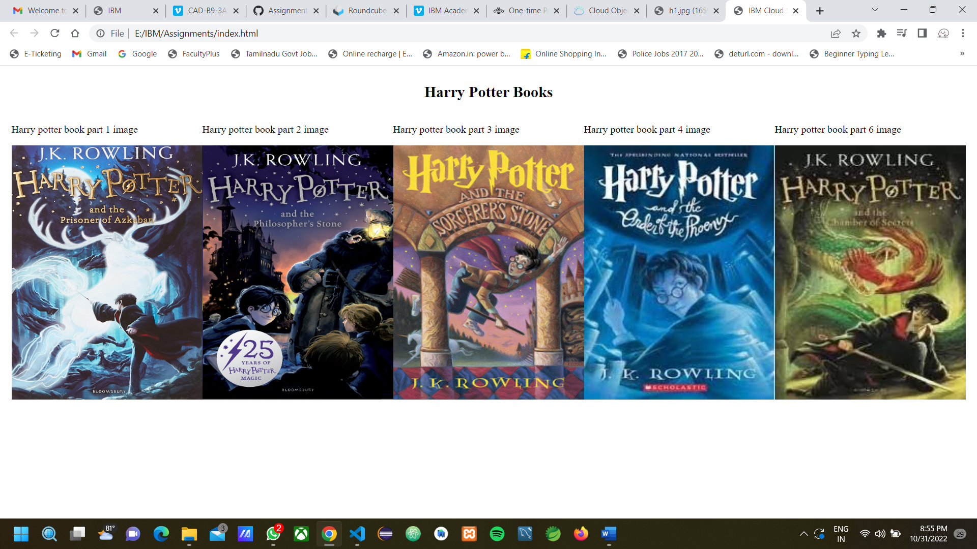

1. Upload a CSS page to the object storage and use the same page in your HTML code.

**Solution:**

<!DOCTYPE html>

<html>

    <head>

        <title>IBM Cloud Storage</title>

        <Link rel="stylesheet" href="http://s3.us-east.cloud-object-storage.appdomain.cloud/insalattabucket/index.css">

    </head>

    <body>

        <h2>Harry Potter Books</h2>

        <div class="wrapper">

            <div>

                <p>Harry potter book part 1 image</p>

                <img src="http://s3.us-east.cloud-object-storage.appdomain.cloud/insalattabucket/h1.jpg" alt="Harry Potter Part 1">

            </div>

            <div>

                <p>Harry potter book part 2 image </p>

            <img src="http://s3.us-east.cloud-object-storage.appdomain.cloud/insalattabucket/h2.jpg" alt="Harry Potter Part 1">

            </div>

            <div>

                <p>Harry potter book part 3 image</p>

            <img src="http://s3.us-east.cloud-object-storage.appdomain.cloud/insalattabucket/h3.jpg" alt="Harry Potter Part 1">

            </div>

            <div>

                <p>Harry potter book part 4 image</p>

            <img src="http://s3.us-east.cloud-object-storage.appdomain.cloud/insalattabucket/h4.jpg" alt="Harry Potter Part 1">

            </div>

            <div>

                <p>Harry potter book part 6 image</p>

            <img src="http://s3.us-east.cloud-object-storage.appdomain.cloud/insalattabucket/h6.jpg" alt="Harry Potter Part 1">

            </div>

        </div>

    </body>

</html>

**Output:**

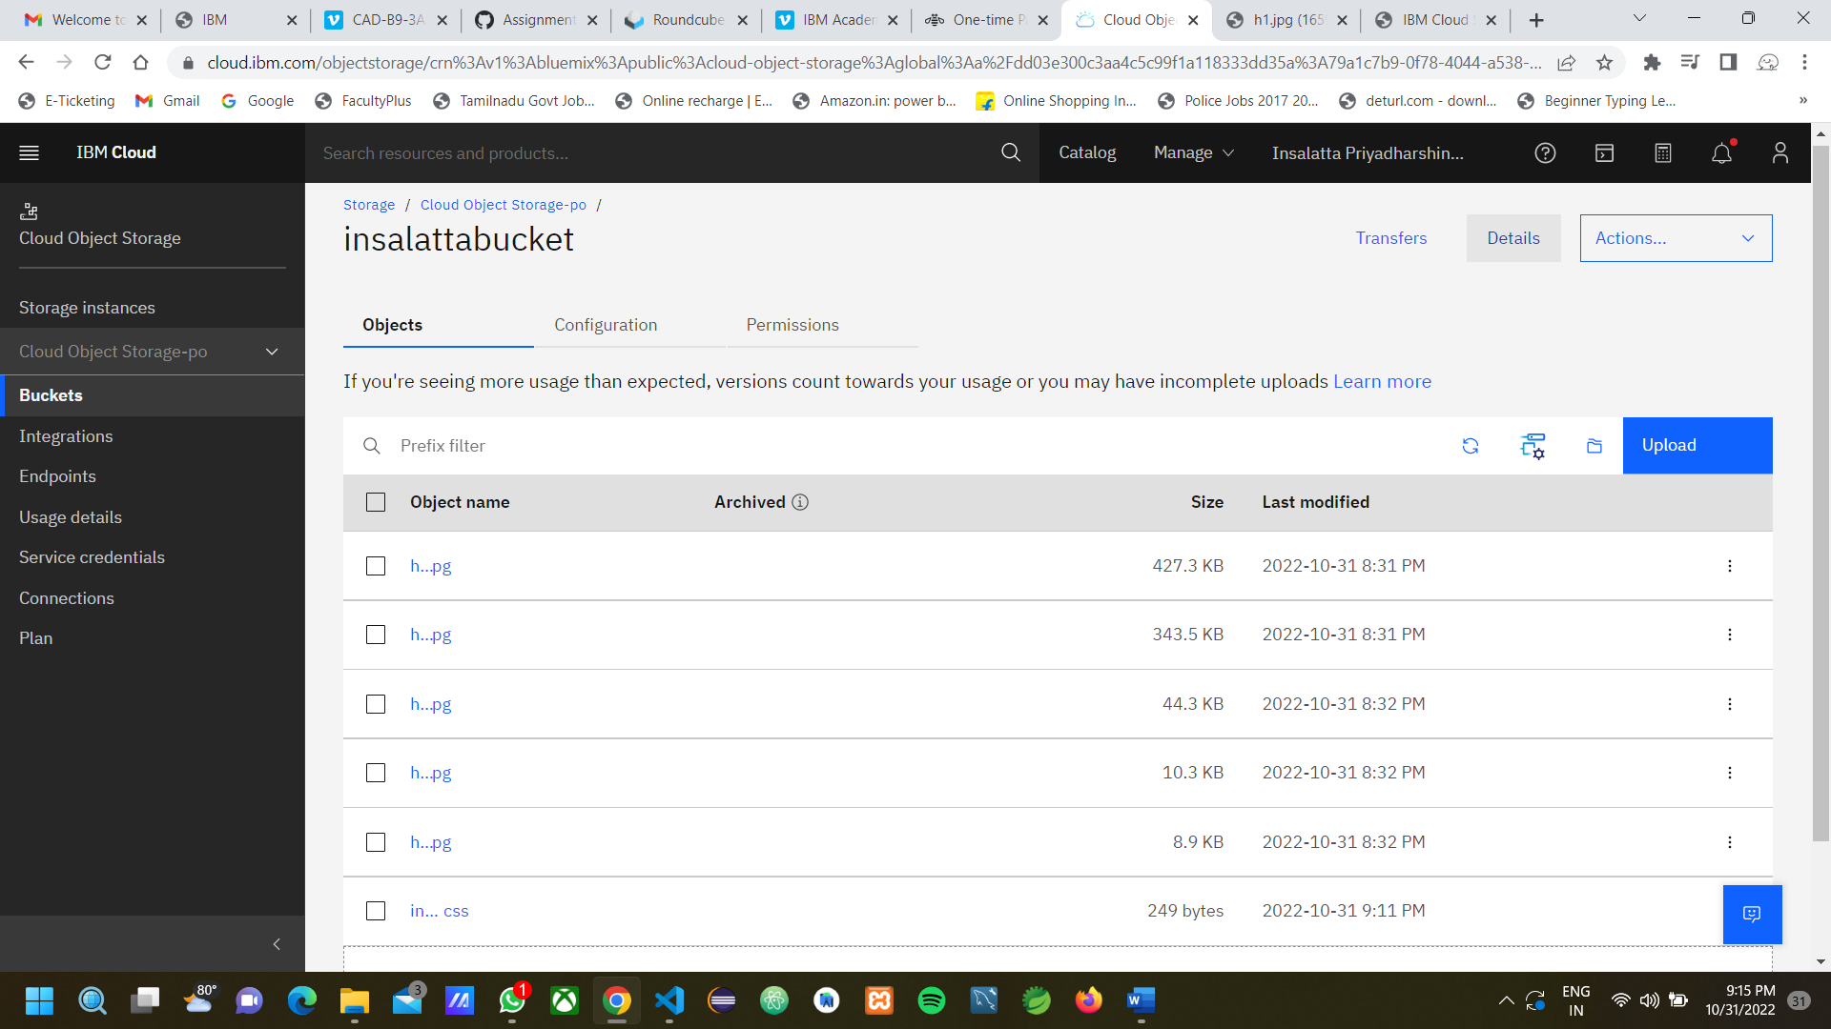



1. Design a chatbot using IBM Watson assistant for hospital. Ex: User comes with query to know the branches for that hospital in your city. Submit the web URL of that chat bot as assignment.

**Solution:**

Web URL of chatbot:

<https://web-chat.global.assistant.watson.appdomain.cloud/preview.html?backgroundImageURL=https%3A%2F%2Fau-syd.assistant.watson.cloud.ibm.com%2Fpublic%2Fimages%2Fupx-c8eca7e5-2f31-4d65-84c9-44e8b5ec57bd%3A%3A0a0cd753-c033-4663-8b47-28675b6d632a&integrationID=f1507087-e15d-46c9-b70f-87617524b30d&region=au-syd&serviceInstanceID=c8eca7e5-2f31-4d65-84c9-44e8b5ec57bd>

1. Create Watson assistant service with 10 steps and use 3 conditions in it. Load that script in HTML page.

**Solution:**

<!DOCTYPE html>

<html>

    <head>

        <meta charset="UTF-8">

        <title>Chatbot page</title>

        <style>

            header{

                display:flex;

                justify-content: center;

                align-items: center;

                flex-direction: column;

                color:midnightblue;

            }

            main{

                display:flex;

                justify-content: center;

                align-items: center;

                flex-direction: column;

            }

            body{

                margin:20px;

                padding:20px;

                border:1px solid black;

            }

            .img{

                text-align: center;

            }

            h3{

                color:midnightblue;

            }

        </style>

    </head>

    <body>

        <header>

            <h2>GALAXY HOSPITAL</h2>

            <p>Your health is our primary concern.</p>

        </header>

        <main>

            <section>

                <h3>Introduction</h3>

                    <p>A hospital is a health care institution providing patient treatment with specialized health science and auxiliary healthcare staff and medical equipment.[2] The best-known type of hospital is the general hospital, which typically has an emergency department to treat urgent health problems ranging from fire and accident victims to a sudden illness. A district hospital typically is the major health care facility in its region, with many beds for intensive care and additional beds for patients who need long-term care. Specialized hospitals include trauma centers, rehabilitation hospitals, children's hospitals, seniors' (geriatric) hospitals, and hospitals for dealing with specific medical needs such as psychiatric treatment (see psychiatric hospital) and certain disease categories. Specialized hospitals can help reduce health care costs compared to general hospitals.[3] Hospitals are classified as general, specialty, or government depending on the sources of income received.</p>

                    <div class="img"><img src="hospital.jpg" alt="hospital image" ></div>

                    <p>A teaching hospital combines assistance to people with teaching to health science students and auxiliary healthcare students. A health science facility smaller than a hospital is generally called a clinic. Hospitals have a range of departments (e.g. surgery and urgent care) and specialist units such as cardiology. Some hospitals have outpatient departments and some have chronic treatment units. Common support units include a pharmacy, pathology, and radiology.</p>

                    <p>Hospitals are typically funded by public funding, health organisations (for-profit or nonprofit), health insurance companies, or charities, including direct charitable donations. Historically, hospitals were often founded and funded by religious orders, or by charitable individuals and leaders.[4]</p>

                    <p>Currently, hospitals are largely staffed by professional physicians, surgeons, nurses, and allied health practitioners, whereas in the past, this work was usually performed by the members of founding religious orders or by volunteers. However, there are various Catholic religious orders, such as the Alexians and the Bon Secours Sisters that still focus on hospital ministry in the late 1990s, as well as several other Christian denominations, including the Methodists and Lutherans, which run hospitals.[5] In accordance with the original meaning of the word, hospitals were original "places of hospitality", and this meaning is still preserved in the names of some institutions such as the Royal Hospital Chelsea, established in 1681 as a retirement and nursing home for veteran soldiers.</p>

            </section>

        </main>

        <script>

            window.watsonAssistantChatOptions = {

              integrationID: "f1507087-e15d-46c9-b70f-87617524b30d", // The ID of this integration.

              region: "au-syd", // The region your integration is hosted in.

              serviceInstanceID: "c8eca7e5-2f31-4d65-84c9-44e8b5ec57bd", // The ID of your service instance.

              onLoad: function(instance) { instance.render(); }

            };

            setTimeout(function(){

              const t=document.createElement('script');

              t.src="https://web-chat.global.assistant.watson.appdomain.cloud/versions/" + (window.watsonAssistantChatOptions.clientVersion || 'latest') + "/WatsonAssistantChatEntry.js";

              document.head.appendChild(t);

            });

          </script>

    </body>

</html>

**Output:**

